# INF10025 Data Management and Analytics

# Task 4 – Pass Submission

Student Number: 104071453  
Student Name: Marco Giacoppo

### Pass 4a

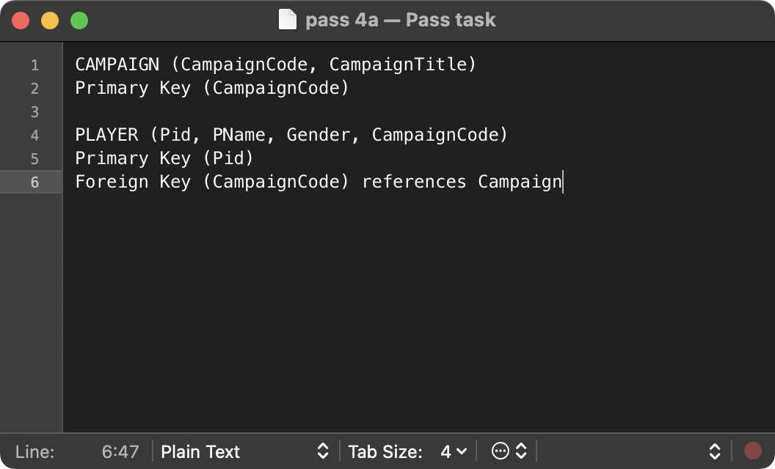

### Pass 4b

### Pass 4c

### Pass 4d

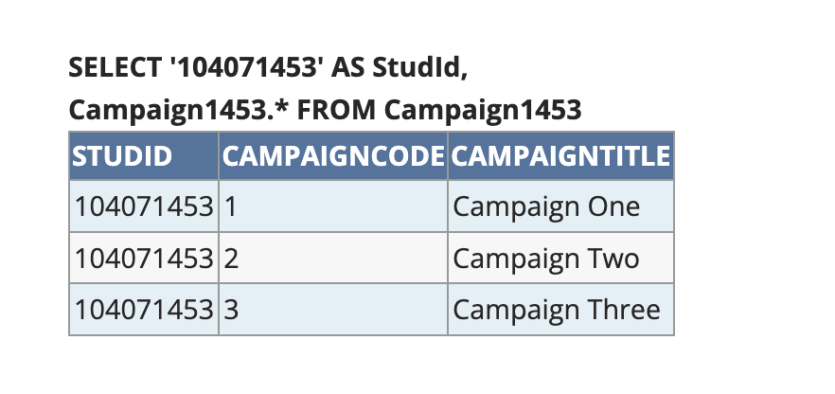

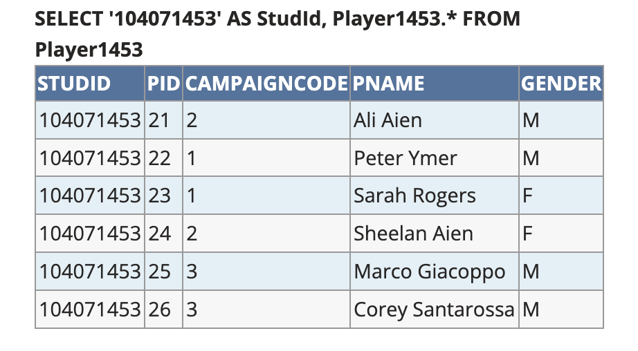

### Pass 4e

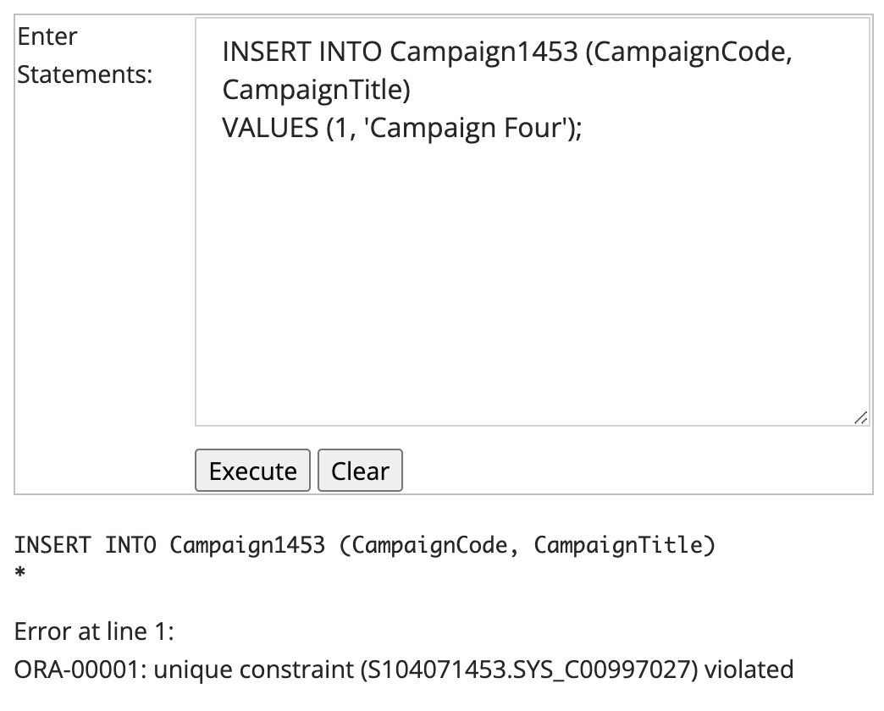

This failed because we tried to insert a new value into an existing primary key, which is not allowed.

Primary key needs to be unique, so there can’t be 2 different values using one primary key.

This failed because we tried to insert a value into a non-existing column. As we can see the CampaignCode is a reference from the parent which is the CampaignTable, which means we need to add a new value of 4 inside the CampaignTable in order for this query to work.

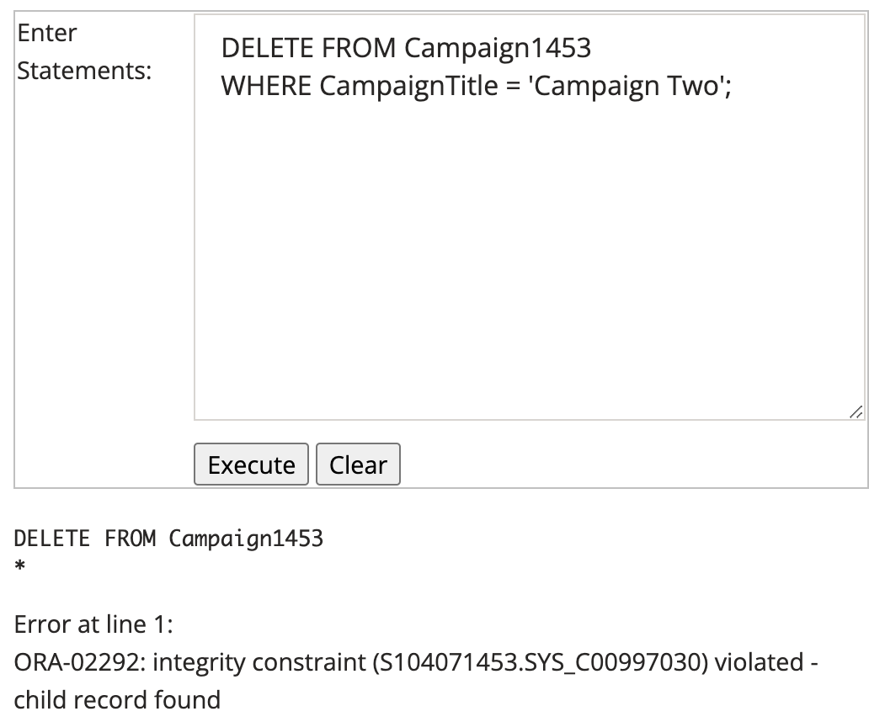

This failed because as it says, there’s a child record found. Which means another table is referencing from this current table. For it to work, we need to remove the relationship from the child table.

### Pass 4f

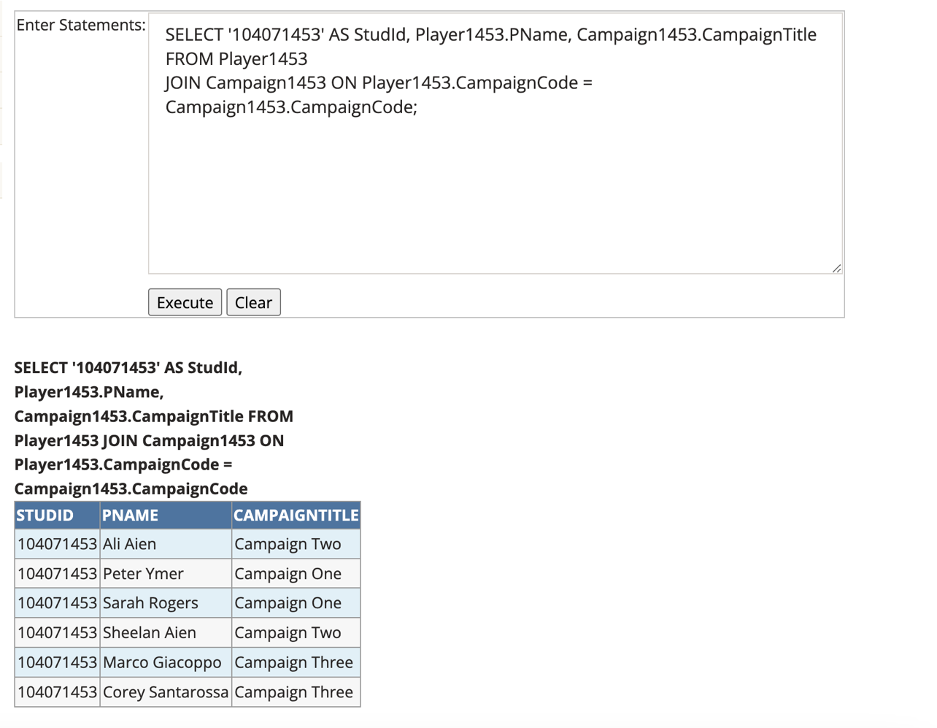

### Pass 4g

### Pass 4h

### Pass 4i

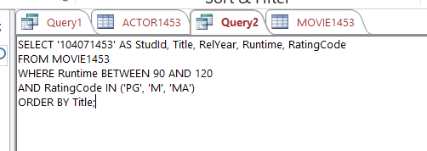

### Pass 4j

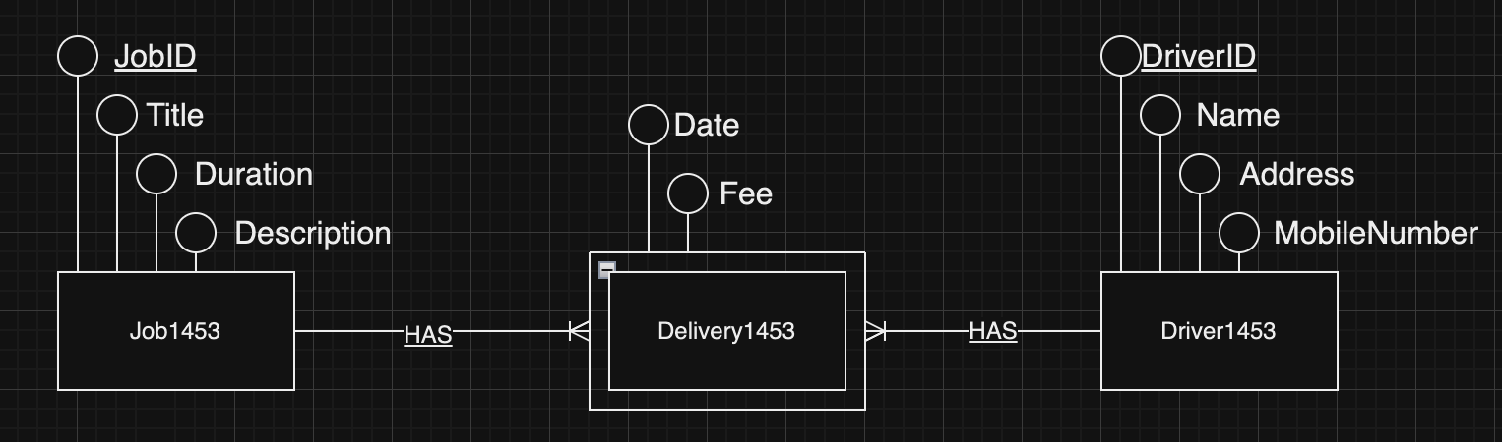

Job1453(JobId, Title, Duration, Description)

Primary Key: JobId

Delivery1453(JobId, DriverId, Date, Fee)

Primary Key: JobId, DriverId

Foreign Key: JobId references Job1453

Foreign Key: DriverId references Driver1453

Driver1453(DriverId, Name, Address, MobileNumber)

Primary Key: DriverId

**TEST DATA:**

INSERT INTO Job1453 (JobId, Title, Duration, Description)

VALUES (‘J1’, ‘Food Pickup’, 2, ‘Pick up food orders’)

INSERT INTO Job1453 (JobId, Title, Duration, Description)

VALUES (‘J2’, ‘Grocery Run’, 1, ‘Buy Groceries’)

INSERT INTO Driver1453 (DriverId, Name, Address, MobileNumber)

VALUES (‘D1’, ‘Alice’, ‘123 Main St, Melbourne’, ‘0412-345-678’)

INSERT INTO Driver1453 (DriverId, Name, Address, MobileNumber)

VALUES (‘D2’, ‘Bob’, ‘456 Elm St, Sydney’, ‘0432-123-456-789’)

INSERT INTO Delivery1453 (DeliveryId, JobId, DriverId, Date, Fee)

VALUES (‘J1’, D1’, ‘2024-04-25’, ‘$10’)

INSERT INTO Delivery1453 (DeliveryId, JobId, DriverId, Date, Fee)

VALUES (‘J2’, ‘D2’, ‘2024-04-26’, ‘$15’)

### Pass 4k

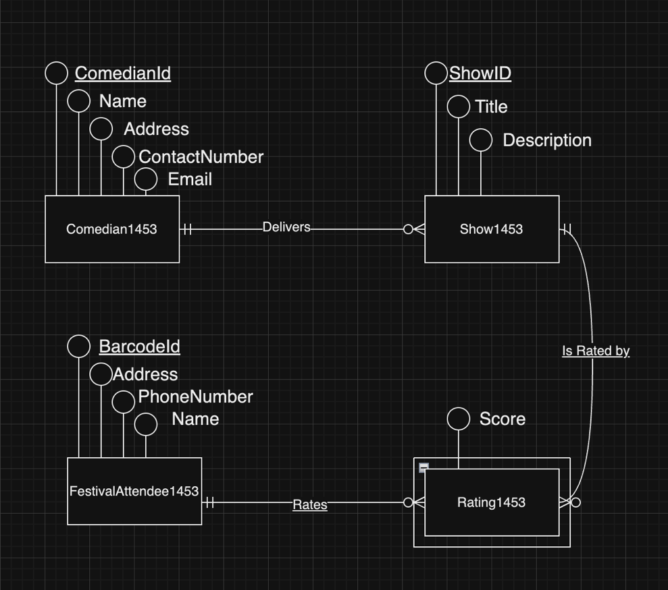

Comedian1453(ComedianId, Name, Address, ContactNumber, Email)

Primary Key: ComedianId

Show1453(ShowId, Title, Description, ComedianId)

Primary Key: ShowId

Foreign Key: ComedianId references Comedian1453

Rating1453 (Score, ShowId, BarcodeId)

Foreign Key: ShowId references Show1453

Foreign Key: BarcodeId references FestivalAttendee1453

FestivalAttendee1453(BarcodeId, Name, Address, PhoneNumber)

Primary Key: BarcodeId

**TEST DATA:**

INSERT INTO Comedian1453 (ComedianId, Name, Address, ContactNumber, Email)

VALUES (C123, 'John Doe', '123 Funny Street', '123-456-7890', 'johndoe@example.com')

INSERT INTO Comedian1453 (ComedianId, Name, Address, ContactNumber, Email)

VALUES (C124, 'Jane Smith', '456 Comedy Avenue', '098-765-4321', 'janesmith@example.com')

INSERT INTO Show1453 (ShowId, Title, Description, ComedianId)

VALUES (S123, 'Laugh Out Loud', 'A stand-up comedy.', C123)

INSERT INTO Show1453 (ShowId, Title, Description, ComedianId)

VALUES (S124, 'Giggle Fest', 'An evening filled with humor and laughter.', C124)

INSERT INTO FestivalAttendee1453 (BarcodeId, Name, Address, PhoneNumber)

VALUES (F123, 'Alice Wonderland', '789 Joy Road', '1111-222-333')

INSERT INTO FestivalAttendee1453 (BarcodeId, Name, Address, PhoneNumber)

VALUES (F124, 'Bob Marvel', '321 Happy Lane', '4444-555-666')

INSERT INTO Rating1453 (RatingId, Score, ShowId, BarcodeId)

VALUES (R123, 8, S123, F123)

INSERT INTO Rating1453 (RatingId, Score, ShowId, BarcodeId)

VALUES (R124, 9, S124, F124)